30-Day Plan

Hit the next 30 days running! In this stage, we'll walk you through a method for planning that optimises your chances of success.
Overview and recommendations
Key dimensions | Self-management
Recommended pace | This stage is a guided planning framework. You may complete this stage as quickly as you would like.
Recommended practice | N/A
Progression tips | This stage is designed for repeated use if you desire. We have found learners who make deliberate plans using this framework face fewer obstacles and can improve their skills more easily and smoothly.

As soon as you have completed this stage, you may move to the next one. There is no minimum recommended practice requirement other than following the instructions for planning.
Lessons
Introduction
Let's kick things off with some basic principles for goal-setting and planning that even experienced professionals often forget!
Goal setting
Did you know that ineffective goal-setting can be harmful? In this lesson, we introduce guidelines on what makes a goal effective.
Performance goals
Trying to achieve an outcome without performance goals is like climbing a mountain without a path. Let's explore the power of performance goals!
Protecting time
Time is your most valuable asset. Yet so few people actively protect it. We'll change that!
Limiting habits and scripted actions
It's thought that over 50% of all our behaviour is driven by habits. Habits can be powerful, but also hold us back.
Environmental optimisation
Environment dictates behaviour. This lesson helps you make effective environmental changes in your 30-day plan.
Pace adjustments

Everyone has their own pace. Let's ensure our plan suits our unique preferences.

Introduction

Accessing your 30-day planner
Open our guided planning form here and fill it in as you learn about each section in the upcoming lessons. You may return to this stage and use this form for future planning as many times as you like!
Key principles
Don’t confuse intention setting with goal setting. Goals involve plans.
SMART goal setting is a good starting point but isn’t enough to optimise success.
Goal setting

This lesson relates to the “Goal Analysis” section of the 30-day plan form.
Key principles
Don’t sacrifice medium to long-term success for short-term outcomes. You may sometimes need to sacrifice short-term outcomes to set yourself up for more meaningful success later. Avoid always playing catch-up for short-term, urgent tasks.
Hard work alone is not enough to achieve uncommon results. The method and direction of your hard work are critical.
Long-term directions are more important than specific goals. This is because many things can change as you gain more information and experience.
Make your goals specific and measurable. Using SMART goals here is appropriate.

Performance goals

Key principles
Performance goals are process and attribute-based.
Performance goals give you crucial early feedback, which provides opportunities for self-correction and adjustment.
Consider these attributes: time management, focus and procrastination, learning efficiency, learning consistency, and stress management.
Pick just a few of the most important attributes to develop in the short term. Avoid overloading yourself and thus failing at all of them.
Performance goals for learning efficiency
Check out this article from the Learning Support page for more guidance on how to think about setting goals for learning efficiency.
Beware your brain (again)
As usual, it appears our brain is trying to sabotage us again! The human brain is notoriously bad at assessing our own abilities and skills.
Beware of thinking, “This doesn’t apply to me” and “I’m different”. Being open-minded carries no risk while helping to prevent us from making unnecessary mistakes and wasting time.
Note
This is especially common among high achievers, who often can safely ignore advice aimed at the general public without consequence.
However, this also means that those who ignore advice have the highest chance of running into issues. As a result, we have found that most learners who struggle with learning the methods we teach in this program are actually high achievers who rushed the fundamentals!

Protecting time
Key principles
Protect your time by avoiding high-risk blocks and preventing anticipated risks from hijacking your time.
If you can't protect a block of time, do not schedule important things there.
Instructions
Schedule the important tasks first.
Identify factors that put your scheduled tasks at risk.
Take steps to protect those tasks. If you can't protect a task, move it to a safer time.
Repeat this process for lower-priority tasks.

Limiting habits and scripted actions
Main points
Identify limiting habits that will sabotage your progress.
Consider how you typically respond to stress, tiredness, lack of time, bad moods, and discomfort.
Think about what factors made you fail to develop a previous habit.
Limiting habits are automatic, and we are usually unaware of them.
It can take you days or weeks to identify your limiting habits. If unsure, the first step is to start paying attention to your habitual response tendencies.
Scripted actions are pre-planned responses that require as close to zero willpower as possible.

Environmental optimisation
Main points
Environmental optimisation is one of the most important things you can do to create focus.
Don’t try to change your behaviour through sheer willpower and effort. People with high levels of consistent productivity invest time and effort in optimising their environment.
Remove bad triggers and make distractions harder to access.
Add good triggers and make good behaviours more convenient to engage in.
Pace adjustments

Fine-tuning our plan

Before we submit our form, we should make some fine-tuned adjustments to the schedule and timing using the tools below.
Once you have finished making these adjustments and created a schedule in your calendar, submit your form to save it. If you want to make a new plan, you can re-access your 30-day plan to resubmit your form again as many times as you want.
Many of our students will create new 30-day plans after finishing their previous ones.
Submitting the form will also unlock the next stage.
Practice vs. theory time
We previously introduced the idea of the theory-practice cycle.
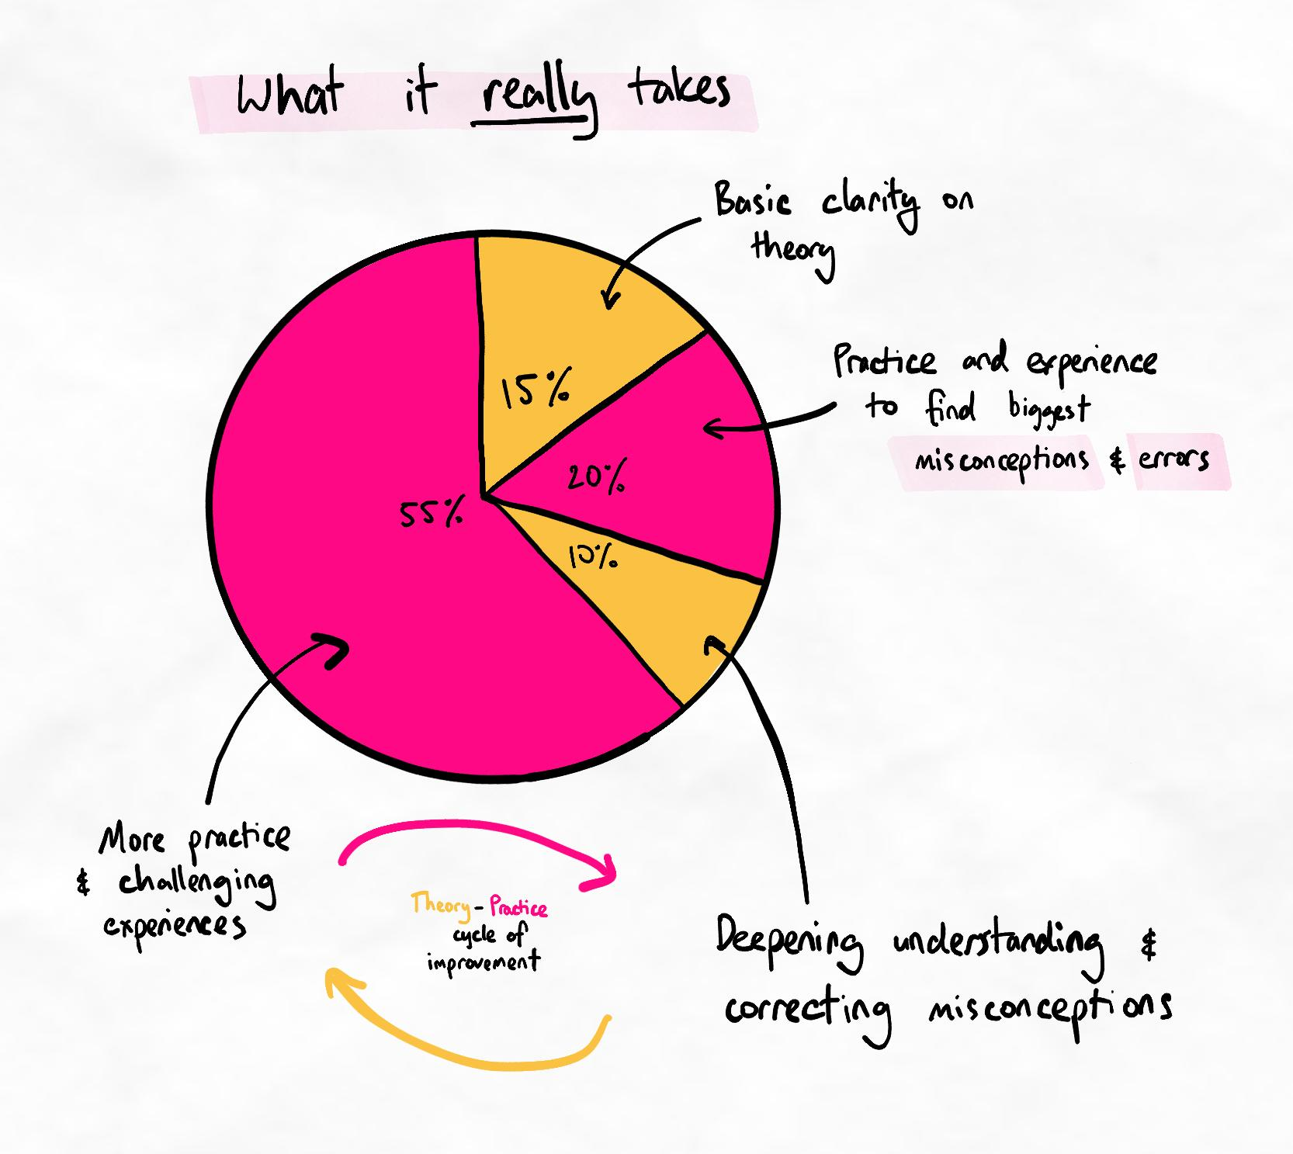The theory-practice cycle occurs when theory is learned in relation to relevant experiences.
We'll now explore this in more depth so that you can adjust your plan to ensure the maximum chance of success in learning new methods. As you can see in the diagram below, most of your learning will happen offline, as you practise theory that you learn online via tasks and techniques.
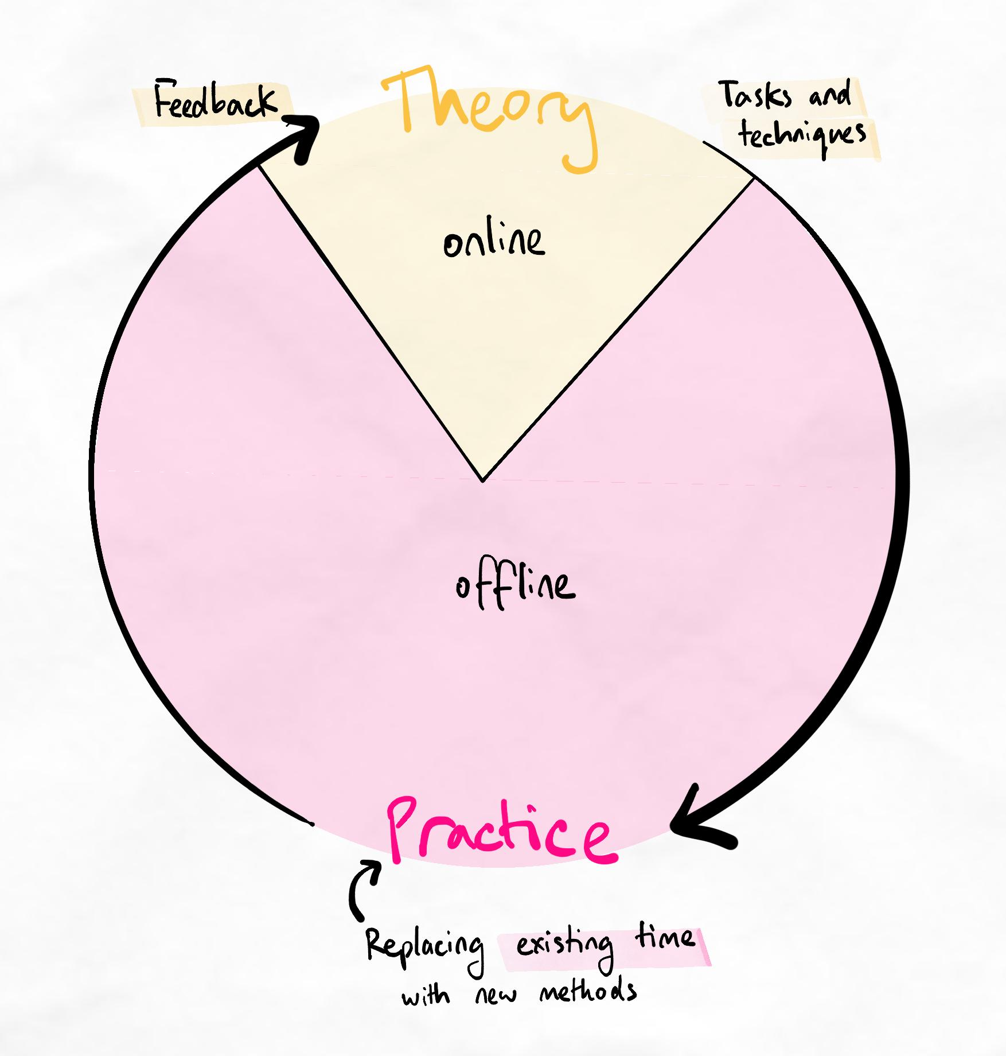A simplified diagram of the theory-practice cycle.
Importantly, most of your "practice time" will be time you are already spending learning. By replacing our current methods with new ones, we can fit lots of practice without spending much "extra" time.

Correct way to practise | Incorrect way to practise
Study similar hours as before, but replace current techniques with new ones learned from this program. | Study similar hours as before using current techniques, then spend extra time to practise new techniques.

Optimising your theory-practice balance
Depending on how much time you commit to learning and studying, you will need to adjust the amount of time you have for theory.
Key principle
To prevent overload, never exceed a 5:1 ratio of practice to theory.
For example, if you spend 25 hours studying per week, then you should spend at most 5 hours on learning theory. Even this may be excessive. Learners have been able to achieve remarkable progress with as high as a 40:1 ratio of practice to theory time.
Additional information
You may wish to read our article on how long to spend on each lesson or stage for further guidance.
Note about the growth phase
Once you enter the growth phase, your progress will slow down. This is because we are entering into a progressive sequence of cognitive retraining.
This process cannot be rushed and requires rock-solid foundations. Our method of retraining is a world-first to maximise your memory and fundamentally change how you process information!

Recommended tasks
Add tasks to your focus list so you can practice the skills.
Dimensions
30-Day Plan
Complete your first 30-day plan
The 30-day plan is a resource you can use as many times as you want. Make sure to hit the first 30 days of your learning journey the right way by completing your plan and saving it.
Complete this task once you have saved your plan and added it to your calendar (like we taught you in the Rapid Start modules).
Remember to keep your spaced interleaved retrieval sessions in your schedule as well!

